Cloud and Devops LAB
WEEK - 5
NAME: B.RISHITH ROLL NO: 22R21A3313
DATE: 20/09/2024
Problem statement - 1
Study and practice git commands
a) Git Installation
b) Create local Repository
c) Configauration of user
a) Git Installation
Steps:
STEP 1. Create a new Ec2 Instance with linux or connect to an existing linux EC2 Sserver
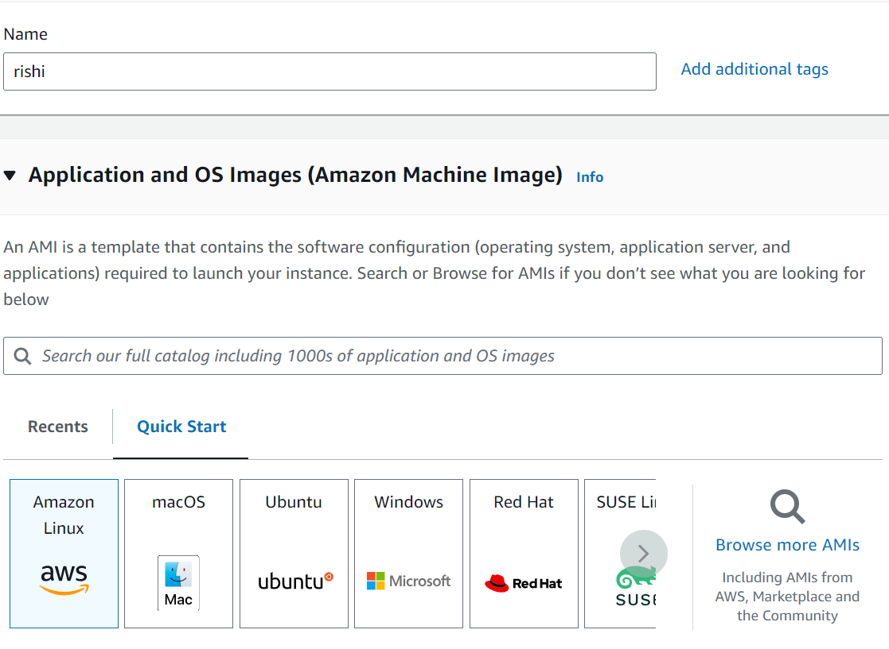

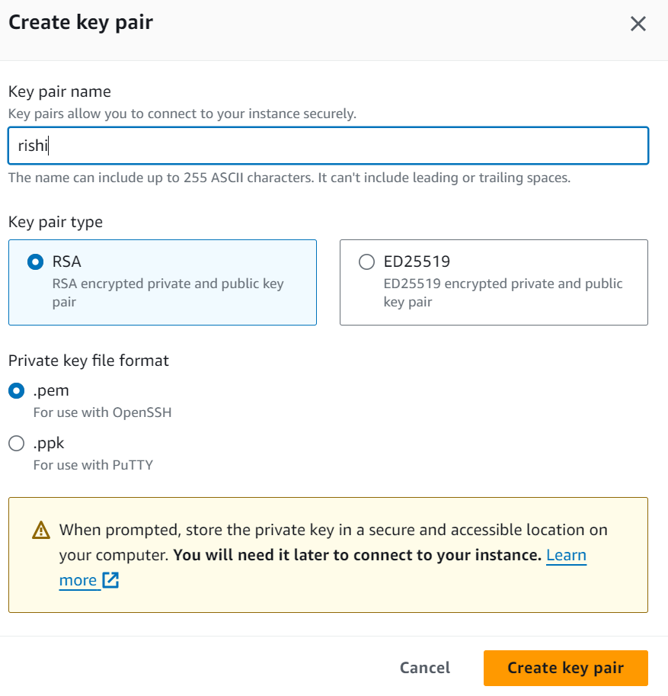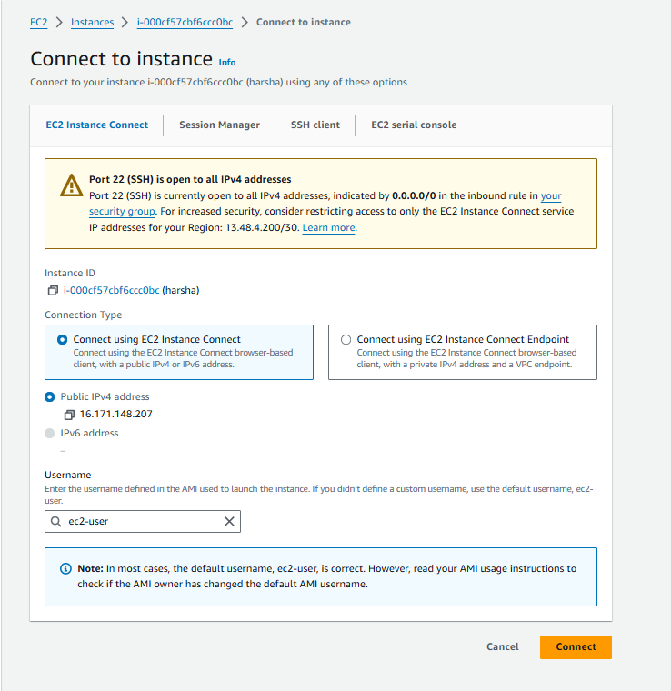

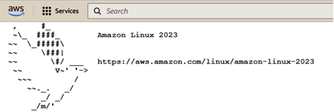
STEP 2: Switch to the user to root by using “sudo –I”
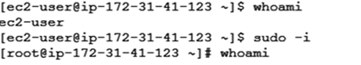
STEP 3: To install the git package use the below command
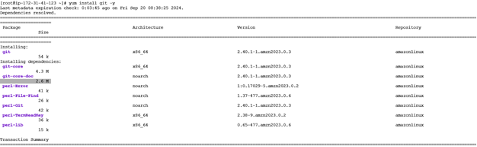
STEP 4:The git is installed successfully in the Ec2 Server
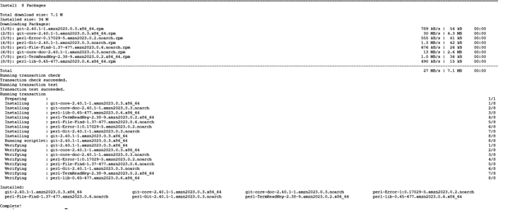
STEP-5:Use Web browser to download git and click on download for windows and click on click here to download
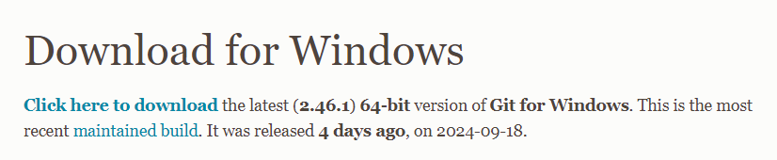
STEP-6:Once Downloaded allow git to make changes to the device once installed launch git and terminal appears
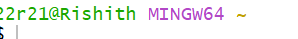
STEP-7:Save the folder with the “Rishi” name on the desktop
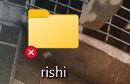
STEP-8:type command “cd desktop/rishi” to change directory
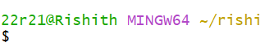
b) Create Local Repository
STEPS:
STEP-1:To Create a local repository use the command “git init”
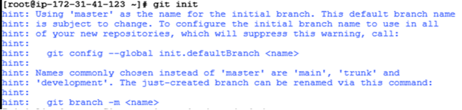
STEP-2: Local Repository with the root name created
STEP-3: Create a file using touch command “touch filename”
STEP-4: Add Content to file using cat command “Cat>filename”
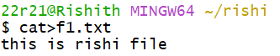
STEP-5: use –ll command to know files in the repository
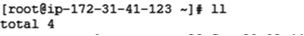
STEP-6: To know status use command “git status”
STEP-7: Add file to git repository using “git add filename”
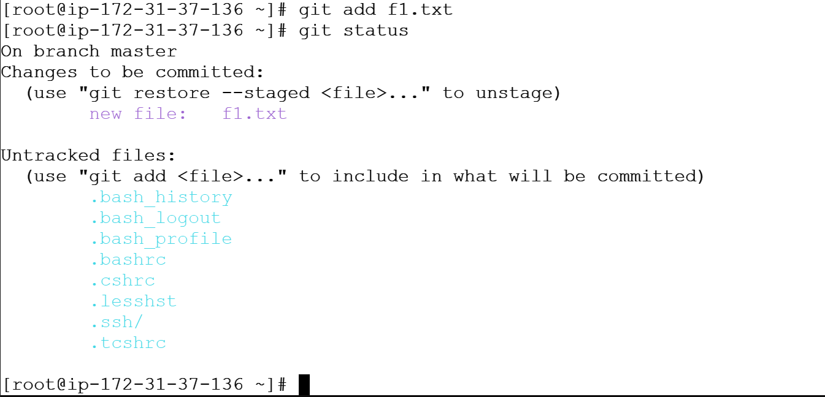
STEP-8: Perform Commit using “git commit –m “message”
STEP-8: use “git log” to know all tasks performed in git

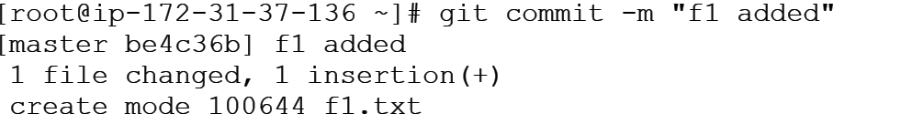

C) Configuration of user
STEPS:
STEP-1: To configure the username of user use git config user.name “Rishi”
STEP-2: To configure the username of user use git config user.email “rishithkumarvikky@gmail.com”
STEP-3: Create a file using touch command “touch filename”
STEP-4: Add Content to file using cat command “Cat>filename”
STEP-5: Perform “git add”
STEP-6: To know status use command “git status”
STEP-8: Perform Commit using “git commit –m “message”
STEP-8: use “git log” to know all tasks performed in git

